Matt Gosselin

Great Flying Fox (current and future) Distribution Prediction

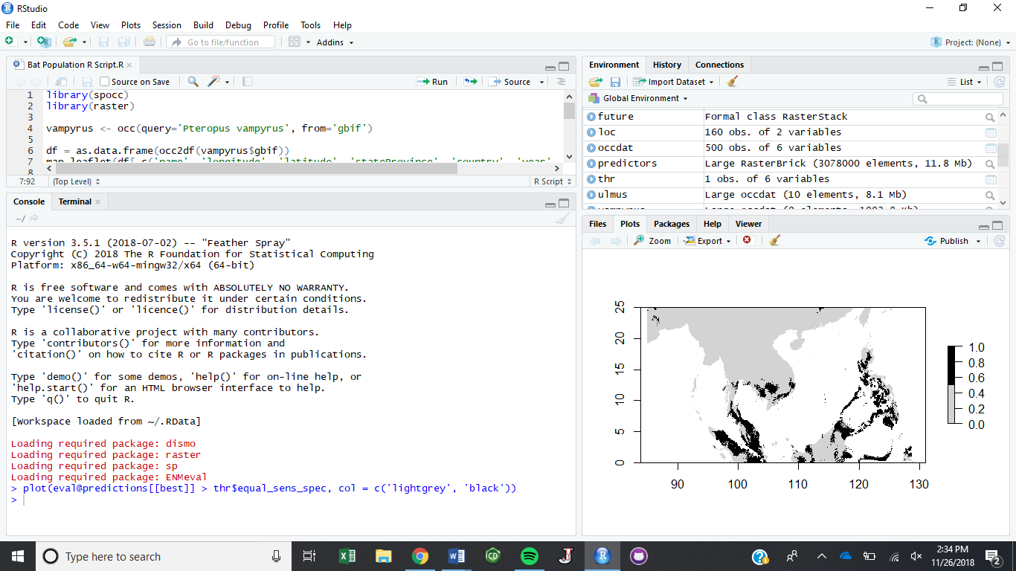

Figure 1. Current Potential Distribution

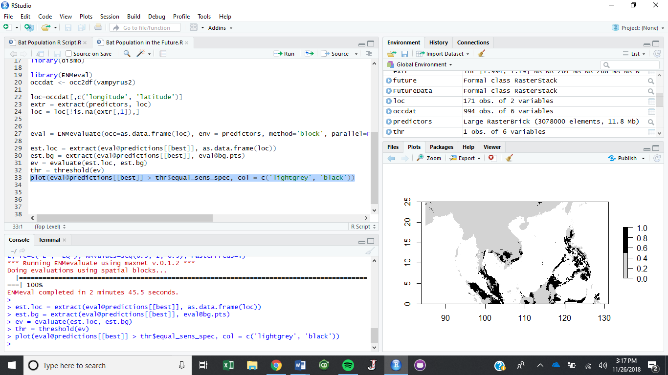

Figure 2. Future Potential Distribution

The future distribution map is mostly the same as the current potential distribution map. At first glance, there is no noticeable difference in the maps. Upon further inspection, one can observe that there are a couple smaller spots which are either a little thicker or a little lighter from one graph to the next. This means that in some areas of Southeast Asia, the Great Flying Fox population will begin to decrease ever so slightly. In other parts of the region, the population will experience small amounts of growth. Overall, since the growth and decline of populations is about equal, the is really no net change in the Flying Fox population, but there is a net movement or redistribution of the Flying Foxes ever so slightly.